Experiment No.6
K-Means and Hierarchical Clustering

PART A: K-MEANS CLUSTERING
import pandas as pd
import numpy as np
import matplotlib.pyplot as plt
from sklearn.cluster import KMeans
from sklearn.preprocessing import StandardScaler
from sklearn.metrics import silhouette_score
# ----------------------------
# 1️⃣ Load Dataset
# ----------------------------
df = pd.read_csv("Mall_Customers.csv")

# Select relevant features
X = df[['Annual Income (k$)', 'Spending Score (1-100)']]
# ----------------------------
# 2️⃣ Feature Scaling
# ----------------------------
scaler = StandardScaler()
X_scaled = scaler.fit_transform(X)
# ----------------------------
# 3️⃣ Elbow Method
# ----------------------------
inertia = []
for k in range(1, 11):
kmeans = KMeans(n_clusters=k, random_state=42, n_init=10)
kmeans.fit(X_scaled)
inertia.append(kmeans.inertia_)
plt.figure()
plt.plot(range(1, 11), inertia, marker='o')
plt.title("Elbow Method")
plt.xlabel("Number of Clusters")
plt.ylabel("Inertia")
plt.show()
# ----------------------------
# 4️⃣ Train Final Model (Assume K=5)
# ----------------------------
kmeans = KMeans(n_clusters=5, random_state=42, n_init=10)
clusters = kmeans.fit_predict(X_scaled)
# Add clusters to dataset
df['Cluster'] = clusters
# ----------------------------
# 5️⃣ Silhouette Score
# ----------------------------
score = silhouette_score(X_scaled, clusters)
print("Silhouette Score:", score)
# ----------------------------
# 6️⃣ Cluster Visualization
# ----------------------------
plt.figure()
plt.scatter(X_scaled[:, 0], X_scaled[:, 1], c=clusters)
plt.title("K-Means Clustering")
plt.xlabel("Annual Income (Scaled)")
plt.ylabel("Spending Score (Scaled)")
plt.show()

Dataset Source
Dataset Name: Mall Customer Segmentation Dataset
Source (Kaggle):https://www.kaggle.com/datasets/vjchoudhary7/customer-segmentation-tutorial-in-python

Dataset Description
This dataset contains customer information from a shopping mall and is used for segmentation analysis.

Dataset Overview:
- Total Records: 200
- Total Features: 5
- Problem Type: Unsupervised Clustering

Features:
Feature | Description
CustomerID | Unique ID
Gender | Male/Female
Age | Customer age
Annual Income (k$) | Yearly income
Spending Score (1-100) | Spending behavior score
For clustering, typically used features:
- Annual Income
- Spending Score

Mathematical Formulation of K-Means
K-Means aims to partition data into K clusters by minimizing intra-cluster variance.

Objective Function:

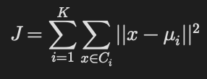
Where:
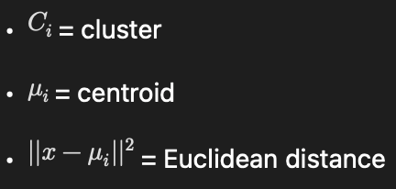

Algorithm Limitations
- Need to specify K manually
- Sensitive to initial centroid selection
- Works only for spherical clusters
- Affected by outliers
- Not suitable for non-globular cluster shapes

Methodology / Workflow
Dataset → Feature Selection → Scaling →
Elbow Method → K-Means Training → Cluster Visualization

Performance Analysis
Since clustering is unsupervised:
- Evaluation Metrics Used:
- Inertia (Within Cluster Sum of Squares)
- Silhouette Score
- Silhouette Score Range: -1 to 1
- Higher value → better cluster separation

Hyperparameter Tuning
Parameter tuned:
- Number of clusters (K)
Method used:
- Elbow Method
- Silhouette Score Optimization
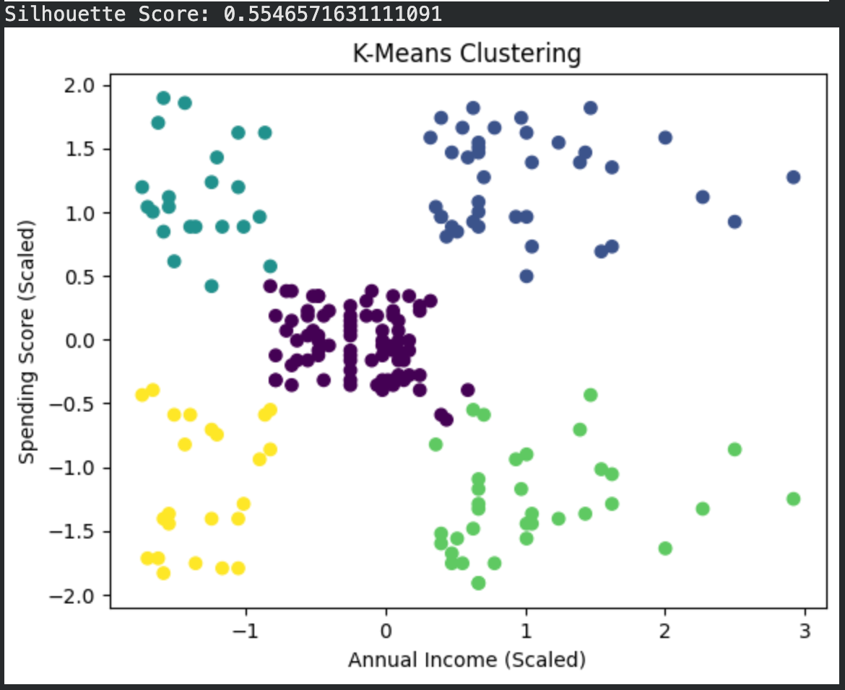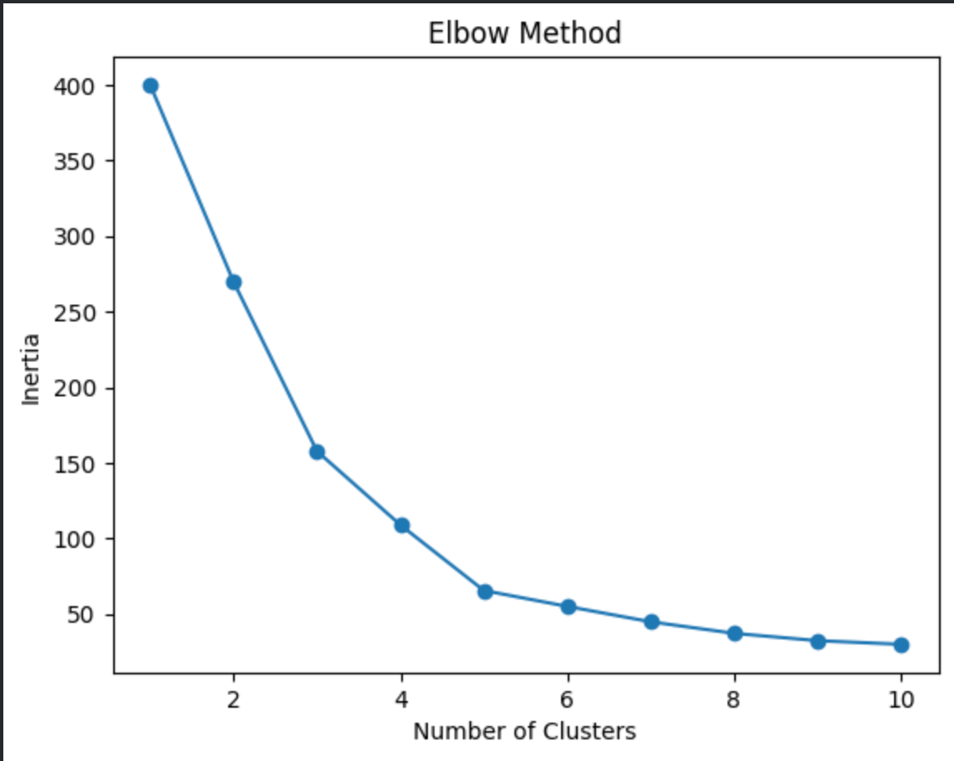

PART B: HIERARCHICAL CLUSTERING
import pandas as pd
import matplotlib.pyplot as plt
import scipy.cluster.hierarchy as sch
from sklearn.preprocessing import StandardScaler
from sklearn.cluster import AgglomerativeClustering
from sklearn.metrics import silhouette_score

# ----------------------------
# 1️⃣ Load Dataset
# ----------------------------
df = pd.read_csv("Wholesale customers data.csv")

# Remove categorical columns if present
if 'Channel' in df.columns:
df = df.drop(['Channel', 'Region'], axis=1)

X = df.values

# ----------------------------
# 2️⃣ Feature Scaling
# ----------------------------
scaler = StandardScaler()
X_scaled = scaler.fit_transform(X)

# ----------------------------
# 3️⃣ Dendrogram
# ----------------------------
plt.figure()
dendrogram = sch.dendrogram(sch.linkage(X_scaled, method='ward'))
plt.title("Dendrogram")
plt.xlabel("Customers")
plt.ylabel("Euclidean Distance")
plt.show()

# ----------------------------
# 4️⃣ Train Hierarchical Model
# ----------------------------
hc = AgglomerativeClustering(n_clusters=3, linkage='ward')
clusters = hc.fit_predict(X_scaled)

# ----------------------------
# 5️⃣ Silhouette Score
# ----------------------------
score = silhouette_score(X_scaled, clusters)
print("Silhouette Score:", score)

# ----------------------------
# 6️⃣ Cluster Visualization (First 2 Features)
# ----------------------------
plt.figure()
plt.scatter(X_scaled[:, 0], X_scaled[:, 1], c=clusters)
plt.title("Hierarchical Clustering")
plt.xlabel("Feature 1 (Scaled)")
plt.ylabel("Feature 2 (Scaled)")
plt.show()

Dataset Source
Dataset Name: Wholesale Customers Dataset
Source (Kaggle): https://www.kaggle.com/datasets/binovi/wholesale-customers-data-set

Dataset Description
This dataset contains annual spending amounts for customers in different product categories.

📊 Dataset Overview:
- Total Records: 440
- Features: 8
- Type: Unsupervised Learning

Features Include:
Feature | Description
Fresh | Annual spending on fresh products
Milk | Spending on milk
Grocery | Grocery spending
Frozen | Frozen products
Detergents_Paper | Cleaning products
Delicassen | Delicacy items

Mathematical Formulation of Hierarchical Clustering
Hierarchical clustering builds nested clusters using linkage criteria.

Distance Between Clusters
Common Linkage Methods:
- Single Linkage:
- D(A,B) = \min d(a,b)
- Complete Linkage:
- D(A,B) = \max d(a,b)
- Average Linkage:
- D(A,B) = \frac{1}{|A||B|} \sum d(a,b)

Algorithm Limitations
- Computationally expensive for large datasets
- Difficult to decide number of clusters
- Sensitive to noise and outliers
- Cannot undo previous merges

Methodology / Workflow
Dataset → Scaling → Distance Matrix →
Agglomerative Clustering → Dendrogram → Cluster Assignment

Performance Analysis
Evaluation Methods:
- Dendrogram visualization
- Silhouette Score
- Cluster compactness
Hierarchical clustering provides better interpretability via dendrograms.

Hyperparameter Tuning
Parameters tuned:
- Number of clusters
- Linkage method (single, complete, average, ward)
Ward linkage often provides better compact clusters.
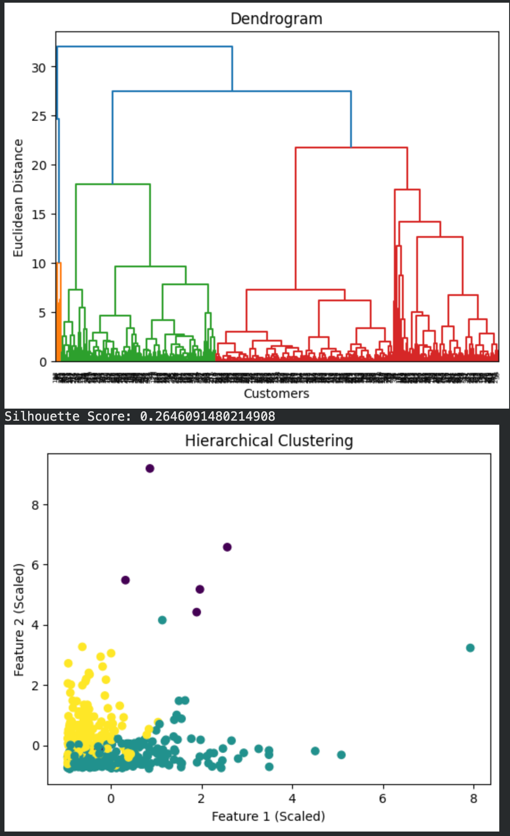

Final Comparative Analysis
Aspect | K-Means | Hierarchical
Need K beforehand | Yes | No
Speed | Fast | Slower
Visualization | Cluster Plot | Dendrogram
Suitable for | Large datasets | Smaller datasets
Interpretability | Moderate | High

Final Conclusion
- K-Means is efficient for large datasets and works well for spherical clusters.
- Hierarchical clustering provides deeper structural insight through dendrograms.
- Feature scaling is essential in both methods
- Choice of clustering method depends on dataset structure and size.

